Library Management System API Documentation
Developed Using: Node.js, Express.js, MongoDB, Mongoose
Database Name: L1F23BSSE0372

1. Project Setup
1. Navigate to your project folder in terminal.
2. Run 'npm init -y' to initialize the Node.js project.
3. Install dependencies:
npm install express mongoose body-parser nodemon
4. Create files: server.js, db.js, and model folders (Book.js, Member.js).
5. Connect MongoDB with your registration number as database name.
6. Start your API server using 'npm start' or 'nodemon server.js'.

2. API Endpoints

POST /lms/books
Add a new book
- Sample Request:
{'bookID': 101, 'title': 'The Science of Everything', 'author': 'John Maxwell', 'genre': 'Science', 'publishedYear': 2022}
- Sample Response:
{'message': 'Book added successfully'}
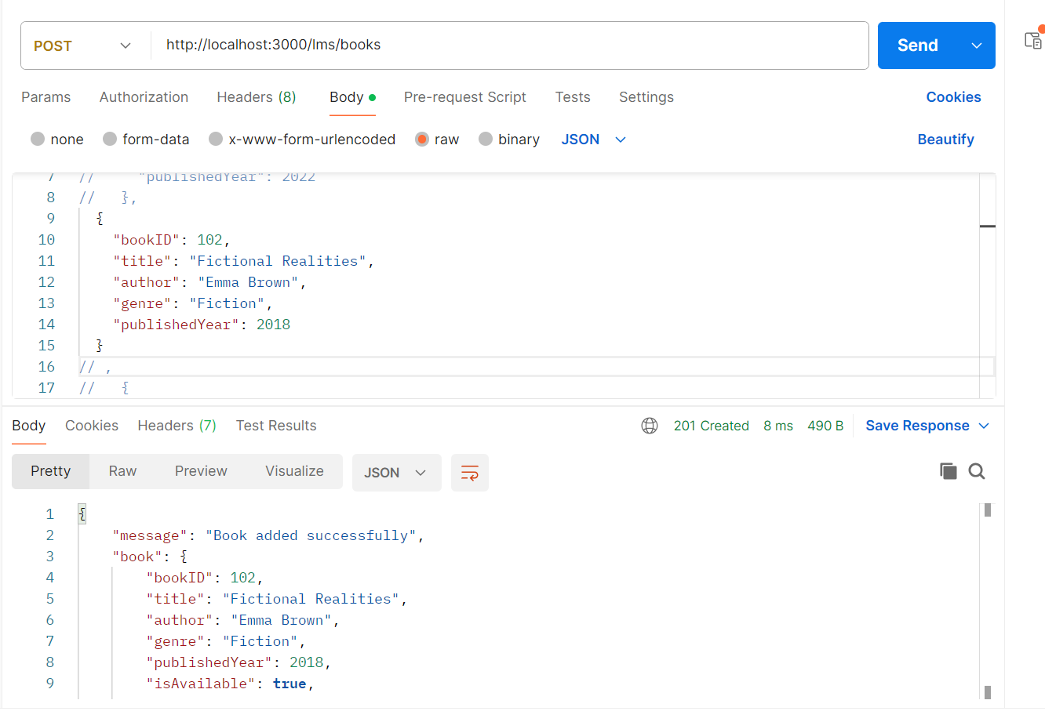

POST /lms/members
Add a new member
- Sample Request:
{'memberID': 201, 'name': 'Alice Johnson', 'email': 'alice.johnson@example.com', 'role': 'student'}
- Sample Response:
{'message': 'Member added successfully'}
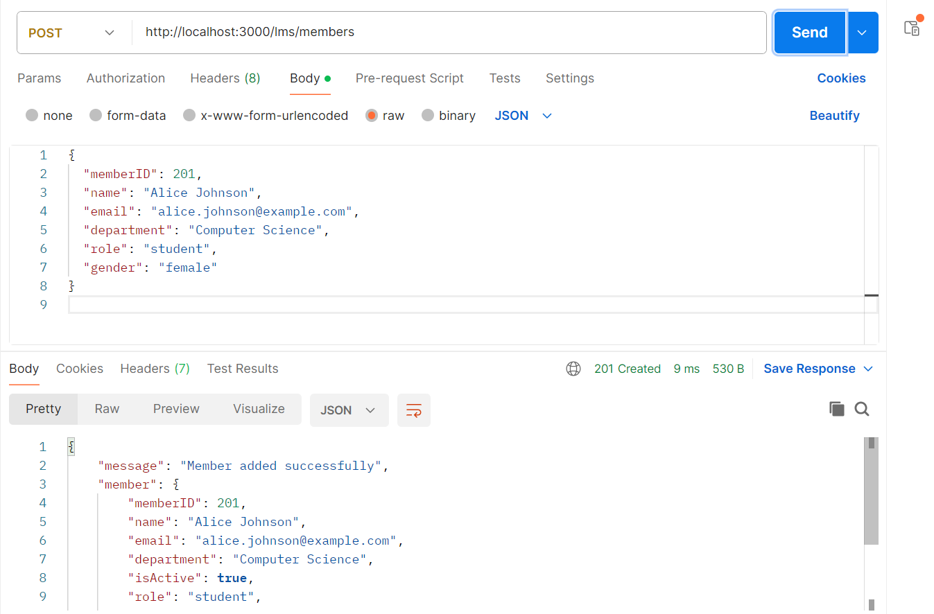

GET /lms/books
Fetch all books
- Sample Response:
[{'bookID': 101, 'title': 'The Science of Everything', 'genre': 'Science'}, {'bookID': 108, 'title': 'Fantasy Tales', 'genre': 'Fiction'}, {'bookID': 107, 'title': 'Physics for Everyone', 'genre': 'Science'}, {'bookID': 106, 'title': 'Superhero Comics Vol.1', 'genre': 'Comics'}, {'bookID': 105, 'title': 'Life of Famous Scientists', 'genre': 'Biography'}]
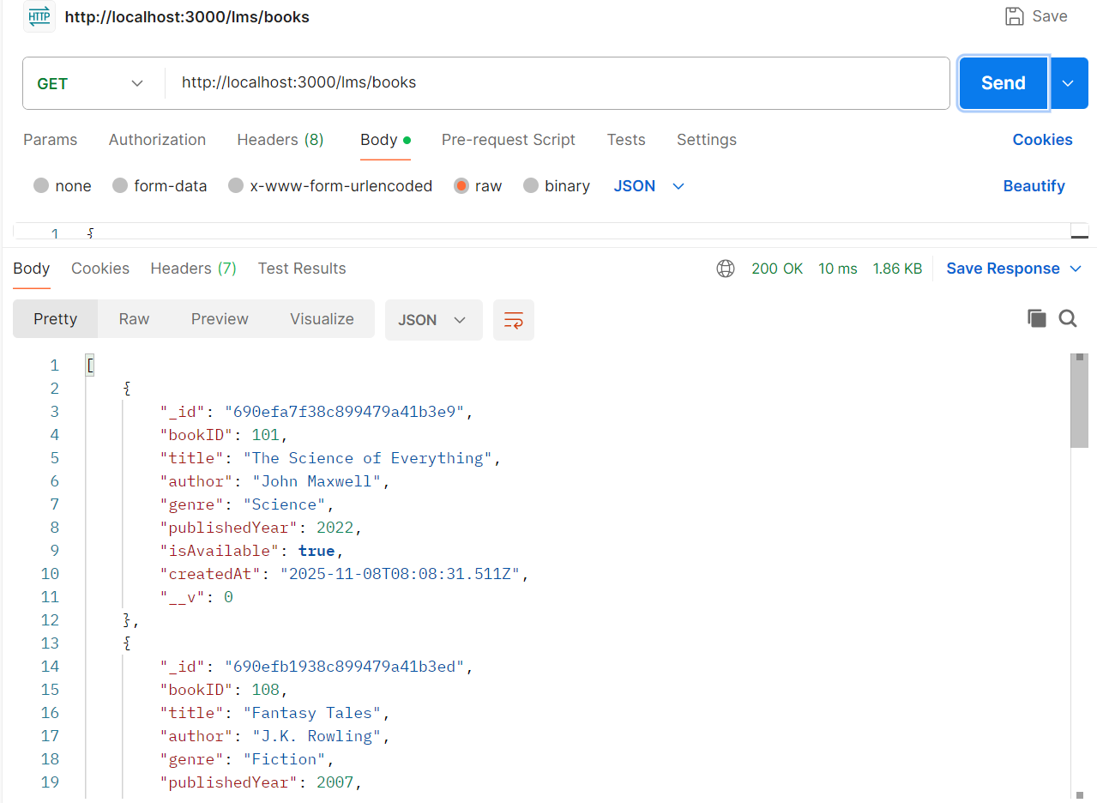

GET /lms/members
Fetch all members
- Sample Response:
[{'memberID': 201, 'name': 'Alice Johnson', 'role': 'student'}, {'memberID': 202, 'name': 'Robert Smith', 'role': 'faculty'}, {'memberID': 203, 'name': 'Maria Garcia', 'role': 'student'}, {'memberID': 204, 'name': 'James Brown', 'role': 'faculty'}]
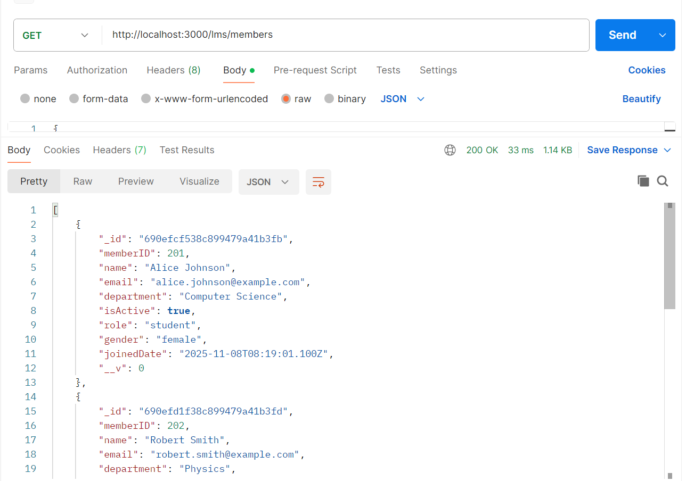

GET /lms/books/available
Fetch all available books
- Sample Response:
[{'bookID': 101, 'title': 'The Science of Everything', 'isAvailable': True}, {'bookID': 108, 'title': 'Fantasy Tales', 'isAvailable': True}, {'bookID': 107, 'title': 'Physics for Everyone', 'isAvailable': True}, {'bookID': 106, 'title': 'Superhero Comics Vol.1', 'isAvailable': True}, {'bookID': 105, 'title': 'Life of Famous Scientists', 'isAvailable': True}]
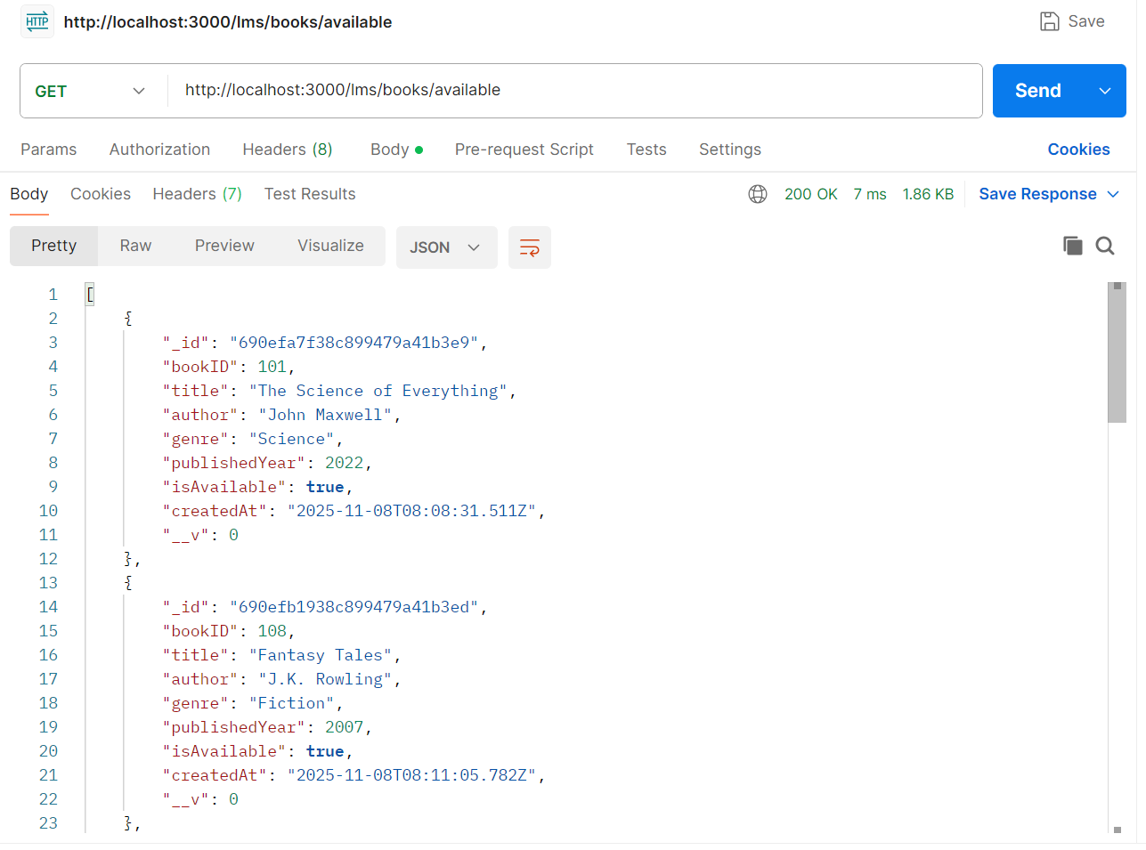

GET /lms/books/issued
Fetch books that are issued
- Sample Response:
[]Empty Because No Book

GET /lms/books/genre/Science
Fetch all Science books
- Sample Response:
[{'bookID': 101, 'title': 'The Science of Everything', 'genre': 'Science'}, {'bookID': 107, 'title': 'Physics for Everyone', 'genre': 'Science'}]
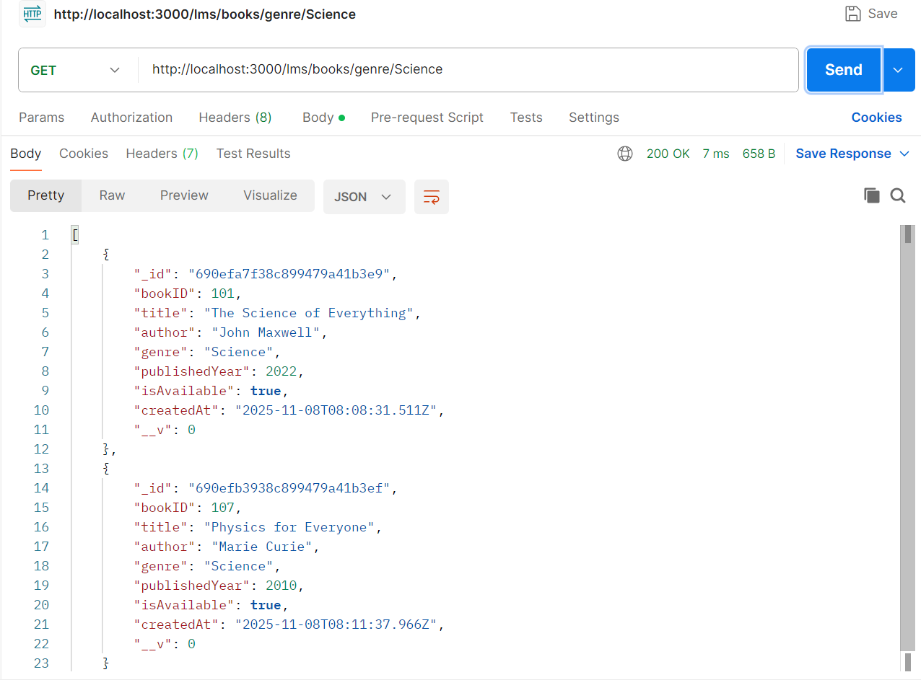

GET /lms/members/recent
Fetch members who joined in the last 60 days
- Sample Response:
[{'memberID': 201, 'name': 'Alice Johnson'}, {'memberID': 202, 'name': 'Robert Smith'}, {'memberID': 203, 'name': 'Maria Garcia'}, {'memberID': 204, 'name': 'James Brown'}]
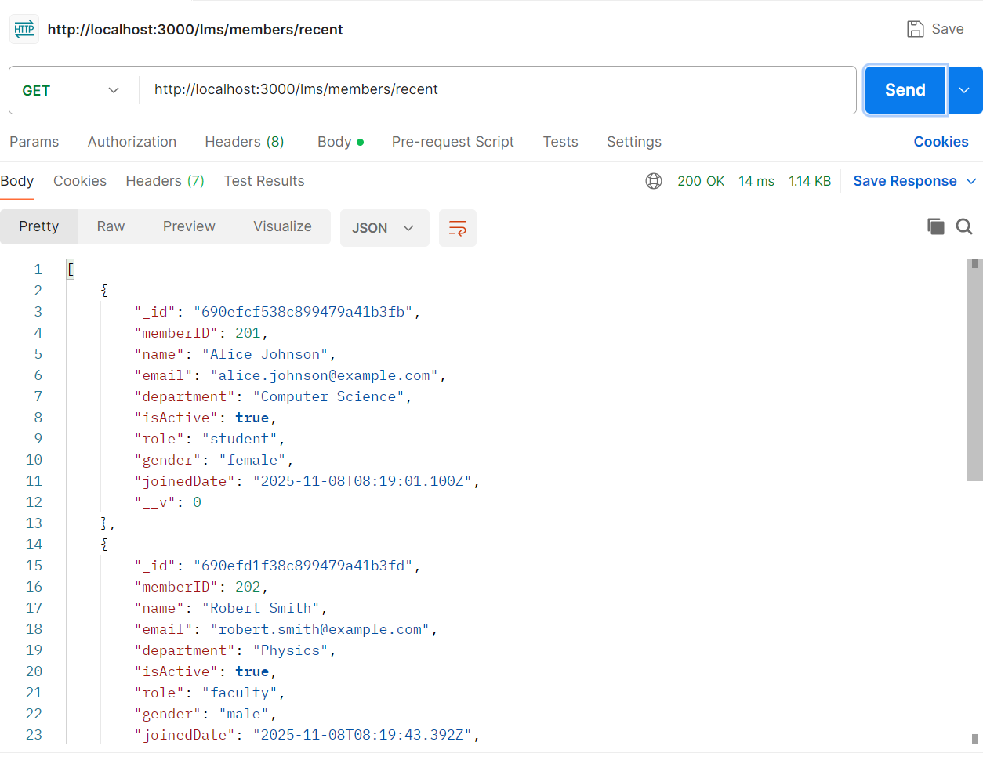

GET /lms/members/role/student
Fetch members with role = student
- Sample Response:
[{'memberID': 201, 'name': 'Alice Johnson'}, {'memberID': 203, 'name': 'Maria Garcia'}]
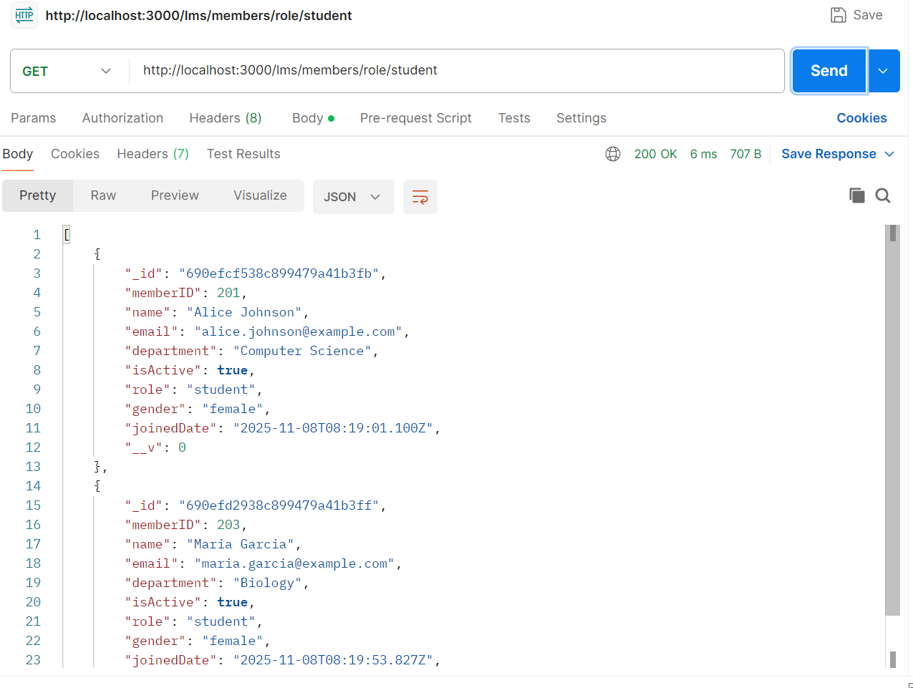

GET /lms/books/available?genre=Science&publishedYear=2022
Fetch available books filtered by genre and year
- Sample Response:
[{'bookID': 101, 'title': 'The Science of Everything', 'genre': 'Science', 'publishedYear': 2022}]
